Accessible Pedestrian Signal (APS)
Field Observation Report
Broadway & West 30th Street, Manhattan • September 30, 2026
Location | Broadway and West 30th Street, Manhattan, New York City
Observation type | Field functional check of APS audible and vibrotactile features
Observed condition | Intermittent / inconsistent APS operation
Primary concerns | Low audible volume; inconsistent chirping/locator tone; inconsistent vibration of tactile arrow
Documentation | 10 field photographs showing APS pushbutton stations and intersection context

Field Findings
- The APS units were present and physically accessible at the intersection, with pushbutton signs and raised directional arrows visible in the photographs.
- During field testing, the audible chirping / locator-tone function was inconsistent. At times the sound was present, but it was not reliably produced throughout testing.
- When audible output was produced, the volume was low, reducing its usefulness for locating the APS and confirming signal information in the surrounding street environment.
- The vibrotactile feature was also inconsistent. The raised arrow did vibrate during some tests, but vibration was not reliably produced on every activation / expected WALK indication.
- Because both the audible and tactile functions were intermittent, a pedestrian relying on nonvisual information could not depend on the APS to provide consistent crossing information.

Functional Significance
NYC DOT describes APS as providing a low locator tone to help a pedestrian find the device and, after activation, a vibrating button plus a rapid beep or voice indication when the WALK interval begins. The observed low-volume and intermittent audible output, together with intermittent tactile vibration, should therefore be investigated as maintenance or operational defects.

Recommended Corrective Action
- Inspect and test each APS pushbutton serving all crossings at Broadway and West 30th Street.
- Verify that the locator tone operates continuously and consistently during the applicable signal intervals and is audible at an effective level under ambient street noise.
- Verify that the audible WALK indication activates consistently and that automatic volume adjustment is functioning properly.
- Verify that the raised tactile arrow vibrates reliably during every applicable WALK interval after activation.
- After repair or adjustment, conduct an on-site functional test through multiple complete signal cycles and document the result.

Photographic Documentation
Selected photographs below document the APS installations, pushbuttons, crosswalk approaches, and intersection context.
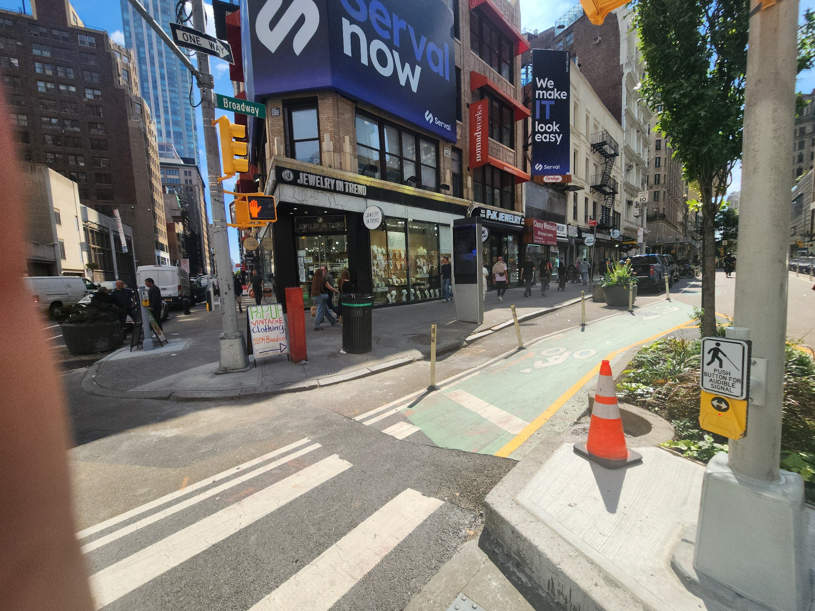
Broadway corner APS pushbutton and crosswalk approach.
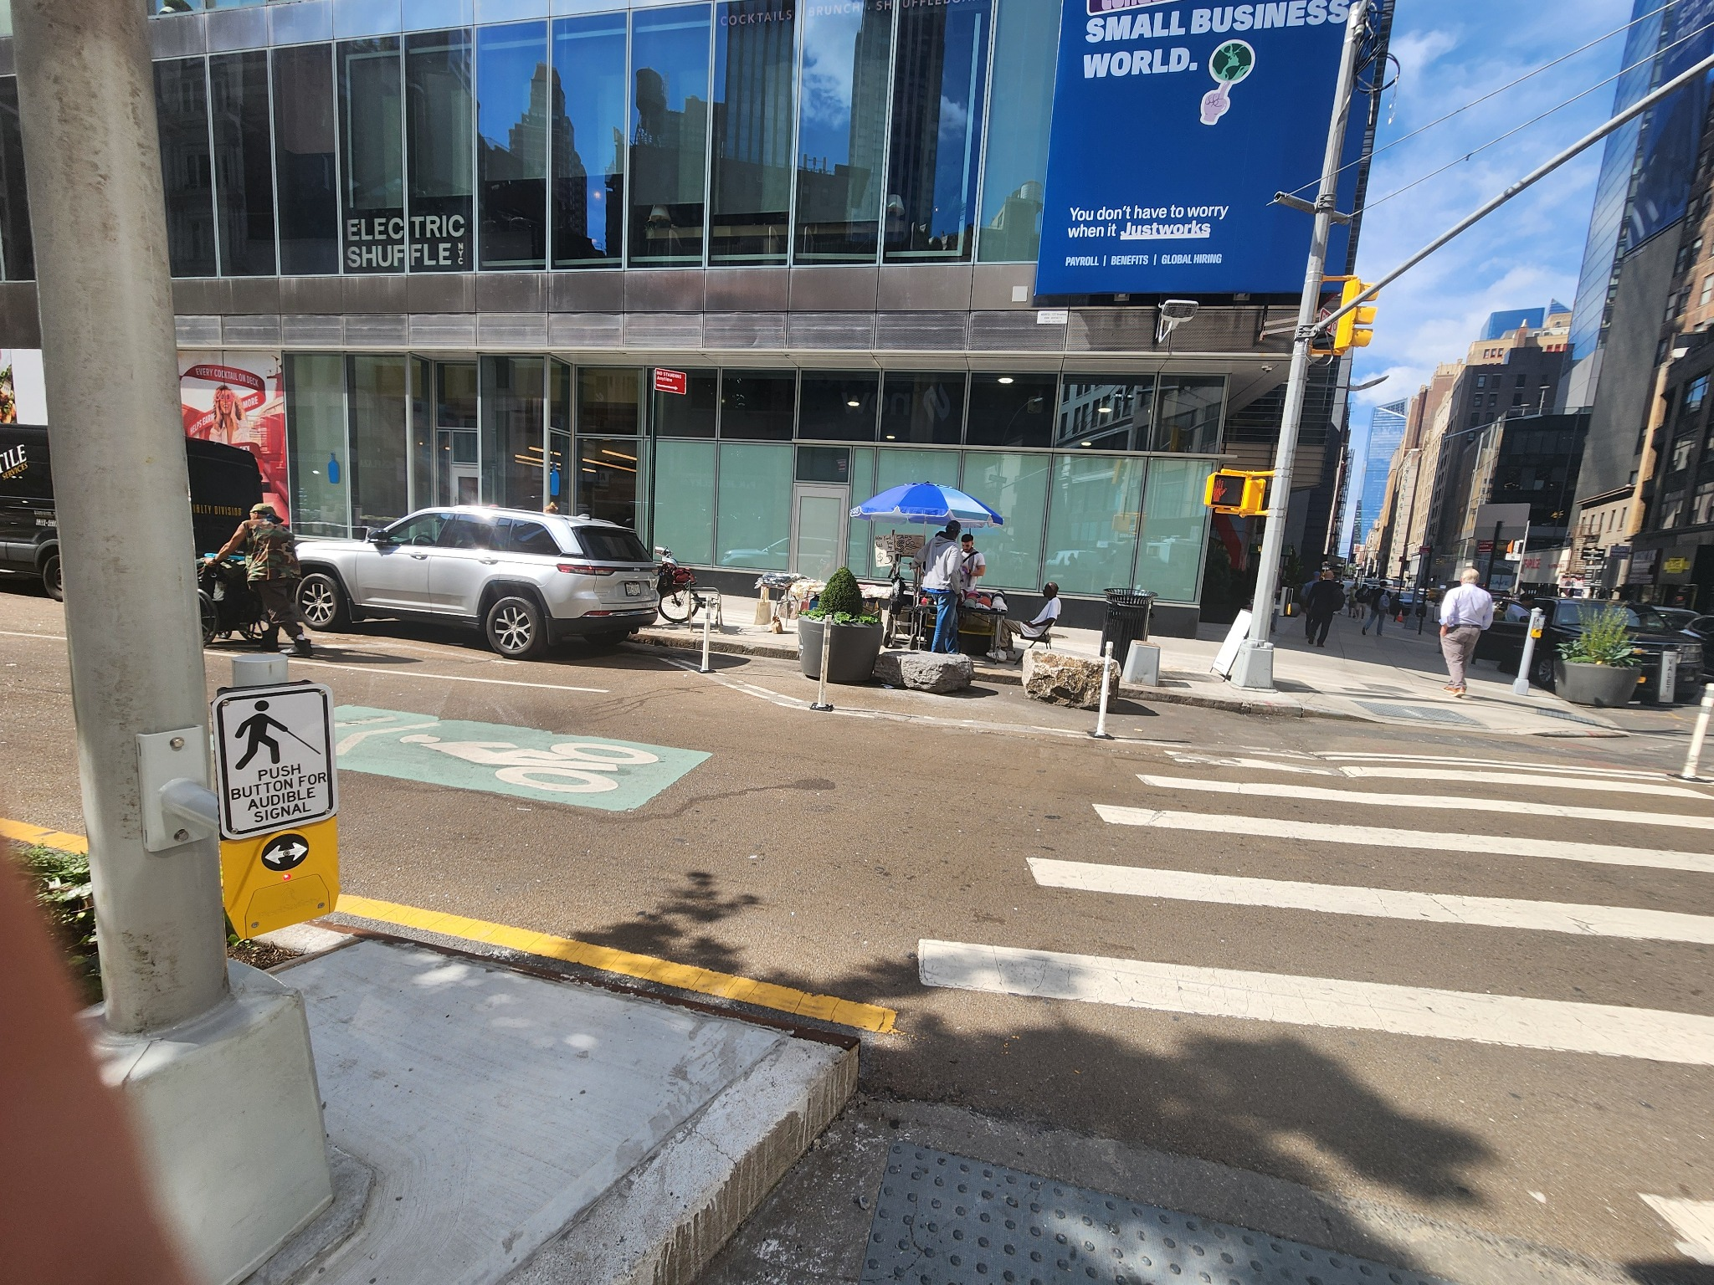
APS pushbutton facing the crossing; intersection and pedestrian signal visible.

Wide intersection view showing APS placement and crossing context.
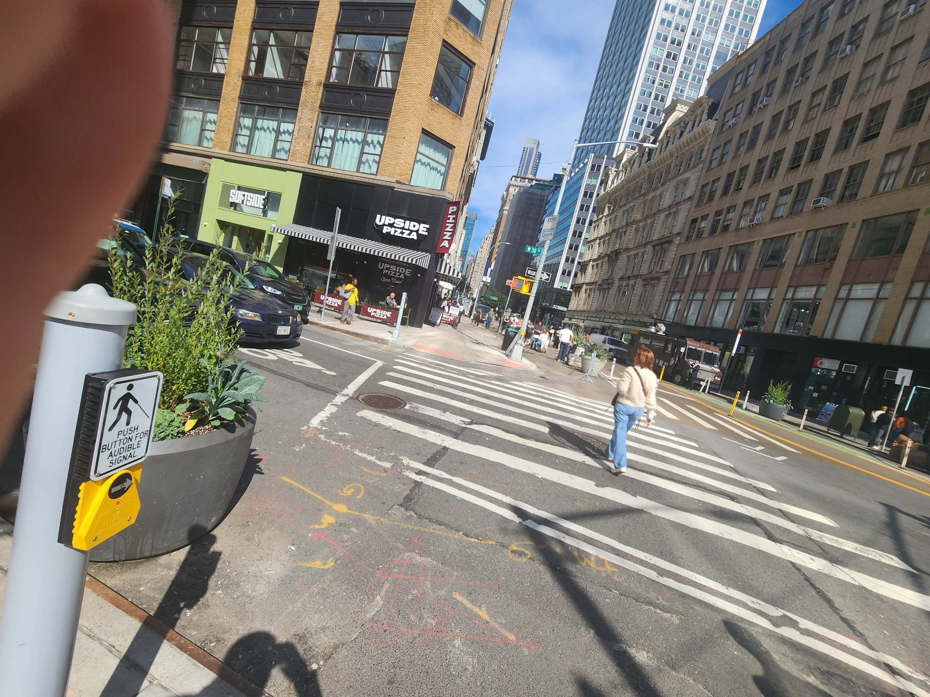
APS pushbutton at the West 30th Street approach.

West 30th Street corner showing APS units on separate poles and curb ramps.

Close view of West 30th Street APS/pedestrian signal assembly.

Reference Standard / NYC DOT Description
NYC DOT's APS specification describes the system as an audible-tactile pedestrian signal with a raised vibrating tactile arrow and audible functions, including a locating tone. It also specifies automatic sound-level adjustment in response to ambient noise. NYC DOT's public APS guidance states that the device plays a low locator tone and that, when the WALK interval begins, the button vibrates and a rapid beep or voice provides the WALK indication.
Sources: NYC DOT, Accessible Pedestrian Signals; NYC DOT Specification 27B, Accessible Pedestrian Signal (APS).

Suggested Complaint Description
APS malfunction – Broadway & West 30th Street, Manhattan. Field testing on September 30, 2026 found inconsistent audible chirping/locator tones at low volume and inconsistent vibration of the tactile arrow. The audible and vibrotactile indications did not operate reliably across repeated activations/signal cycles. Please inspect all APS units at this intersection, correct the volume and intermittent operation, and verify reliable audible and tactile operation through multiple complete signal cycles.

